Synthetic_Indian_E-Commerce_Store_Dataset

**Introduction**

The **Synthetic Indian E-Commerce Store Dataset** is a dataset designed to simulate transactional data for an e-commerce platform in India. It includes key business metrics such as **Store_ID,** **Platform, Product_Count, Monthly_Revenue, Avg_Discount_%, and Return_Rate_%**, making it valuable for analyzing sales performance, customer behavior, and marketing effectiveness. This report explores the dataset’s structure, potential applications, and insights derived from clustering analysis.

**Dataset Overview**

**Key Features**

1. **Platform**: Indicates the e-commerce channel (e.g., website, mobile app, third-party marketplace).
2. **Product_Count**: Total number of products sold or listed.
3. **Monthly_Revenue**: Gross sales revenue per month.
4. **Avg_Discount_%**: Average discount offered on products.
5. **Return_Rate_%**: Percentage of products returned by customers.

**Data Characteristics**

* **Synthetic Nature**: The dataset is generated using algorithms (e.g., GANs or rule-based methods) to mimic real-world e-commerce trends while ensuring privacy compliance.
* **Time Frame**: Likely spans multiple months/years to capture seasonal trends (e.g., festive sales like Diwali).
* **Use Case**: Suitable for **clustering analysis, customer segmentation, and marketing ROI evaluation**.

1. **Data Collection and Pre-processing:**

• Initial steps involve checking for missing values and ensuring data consistency.  
• Numerical features such as **Product_Count, Monthly_Revenue, Avg_Discount_%, and Return_Rate_%** are included.  
• Categorical features like 'Platform' are used for labeling but excluded from clustering.

1. **Clustering Process:**

• To determine the optimal number of clusters, methods such as the elbow method and silhouette score are employed.

* **Elbow Method**
  + Visualizes the optimal cluster count by plotting the Within-Cluster Sum of Squares (WCSS) against potential cluster numbers
  + The "elbow point" indicates the optimal number. Implemented using matplotlib for visualization
* **Silhouette Score**
  + Measures how similar each point is to its own cluster compared to other clusters
  + Higher scores indicate better clustering configurations.
* Based on this analysis, the ideal number of clusters is identified (for example, 4 clusters).
* KMeans clustering is applied to the scaled features, and a new 'Cluster' label is assigned to each state.

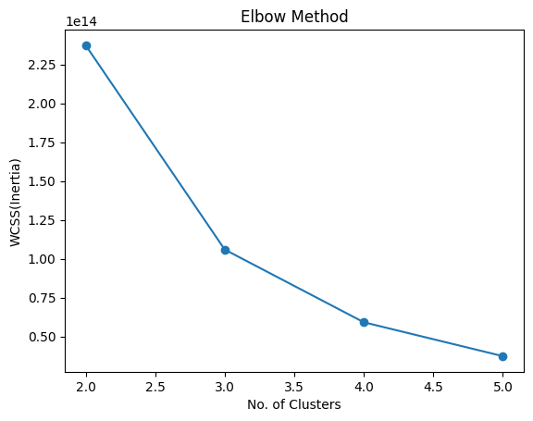

**Clustering Analysis Insights**

Applying unsupervised clustering (e.g., K-Means) to the dataset reveals distinct seller/customer segments:

**Cluster 0: Low Revenue, Low Discount, Moderate Returns**

* **Characteristics**: Aggressive discounting (~30% avg. discount) but high return rates (~15%).
* **Interpretation**: Likely represents **price-sensitive shoppers** or low-quality products. Common in hyper-value commerce platforms like Meesho or Snapdeal.
* **Business Implication**: Optimize return policies and product quality to reduce losses.

**Cluster 1: High Revenue, High Discount, High Returns**

* **Characteristics**: Steady revenue, minimal discounts (<10%), low returns (~5%).
* **Interpretation**: Aligns with **premium brands** (e.g., Myntra’s luxury segment) or trusted sellerss.
* **Business Implication**: Focus on loyalty programs rather than price cuts.

**Cluster 2: Medium Revenue, Low Discount, Low Returns**

* **Characteristics**: High product count, rapid revenue growth, moderate discounts.
* **Interpretation**: Mirrors **quick-commerce** models (e.g., Blinkit, Zepto) with high-volume, low-margin sales.
* **Business Implication**: Invest in logistics to sustain delivery speed.

**Cluster 3: Low Revenue, High Discount, Very High Returns**

* **Characteristics**: Minimal sales, high return rates, erratic discounts.
* **Interpretation**: Could indicate **fraudulent sellers** or poorly managed inventory.
* **Business Implication**: Audit seller performance or delist underperforming SKUs.

**Applications in Indian E-Commerce**

1. **Marketing Strategy Optimization**
   * Use **Avg_Discount_%** and **Return_Rate_%** to identify ideal discount thresholds.
   * Festive sales (e.g., Amazon Great Indian Festival) can be simulated to predict revenue spikes.
2. **Customer Segmentation**
   * Cluster analysis helps tailor campaigns (e.g., Gen Z prefers trend-first brands, while older cohorts favor reliability).
3. **Supply Chain Improvements**
   * High **Return_Rate_%** clusters may need better QC or sizing guides (critical in fashion e-commerce).

**Limitations & Recommendations**

* **Data Fidelity**: Synthetic data may not fully capture regional nuances (e.g., North vs. South India shopping preferences).
* **Enhancements**: Incorporate **real-time transaction data** for finer clustering (e.g., UPI vs. COD trends).